**Learning Objectives**

* To learn about form.
* To grasp concrete uses of such input tags as <input type='text'>, <input type='password'>, <textarea>, <radio>, <checkbox>, <select>, <input type='file'> and </button>.

**Learning Contents**

* Form is normally used in such scenarios as bank card application, login and registration. It includes various types of input, e.g. <input type='text'>, <radio> and <checkbox>, to be filled in by users for the purpose of providing data for the system. Form is one of main interaction content between users and web or application. It allows users to send data to web.
* HTML form is normally composed of one or more components. These small components may be <input type='text'>, <textarea>, <select>, </button>, <checkbox> or <radio>.
* HTML document of form differentiates from other common HTML documents in the following points: in most cases, data collected from form is sent to web server. Then it is necessary to set a web server separately to receive and process data request, but it is not necessary for HTML documents, which can just run locally in a correct way.
* Basic forms are shown as below:

<form action="/echo" method="POST">

<p>User name: <input type="text" name="username"></p>

<p>Password: <input type="password" name="password"></p>

<p><button type="submit">Log in</button></p>

</form>

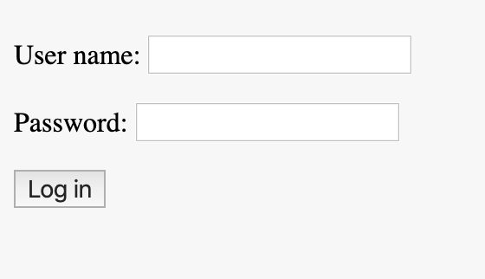

* It mainly contains the following types of widgets:
  + <input type='text'>
  + <input type='password'>
  + <textarea>
  + <radio>
  + <checkbox>
  + <select>
  + <select multiple>
  + <input type='file'>
  + time and date - <input type="date">/<input type="datetime-local">/<input type="month">/<input type="week">/<input type="time">
* Common attributes in HTML form
* action - Request address sent to server;
* method - HTTP request type to be sent;
* name - Form name;
* target - Window name used to send a request and receive a response;
* value - Value corresponding to a specific form item;
* placeholder - Placeholder of a input box; when the input box is blank, the placeholder will appear;
* checked - It relates to <radio> and <checkbox>. It is checked by default.
* Form design principles:
  + Help users to avoid errors to the largest extent;
  + Remind users of filling errors as earlier as possible;
  + Maximize selection/click area;
  + Group form controls when there are many such controls;
  + Distinguish primary actions and secondary actions during form design.

**Recommended Resources**

* Comprehensive Summary of Form Operations in Javascript (<https://juejin.im/entry/58faf918570c350058d497b4>)
* Knowledge Points Related to Form in Javascript (<https://www.cnblogs.com/tugenhua0707/p/4508986.html>)
* HTML Form Preview (<https://developer.mozilla.org/en-US/docs/Learn/HTML/Forms>)
* HTML Input Attribute (<https://www.w3schools.com/tags/tag_input.asp>)